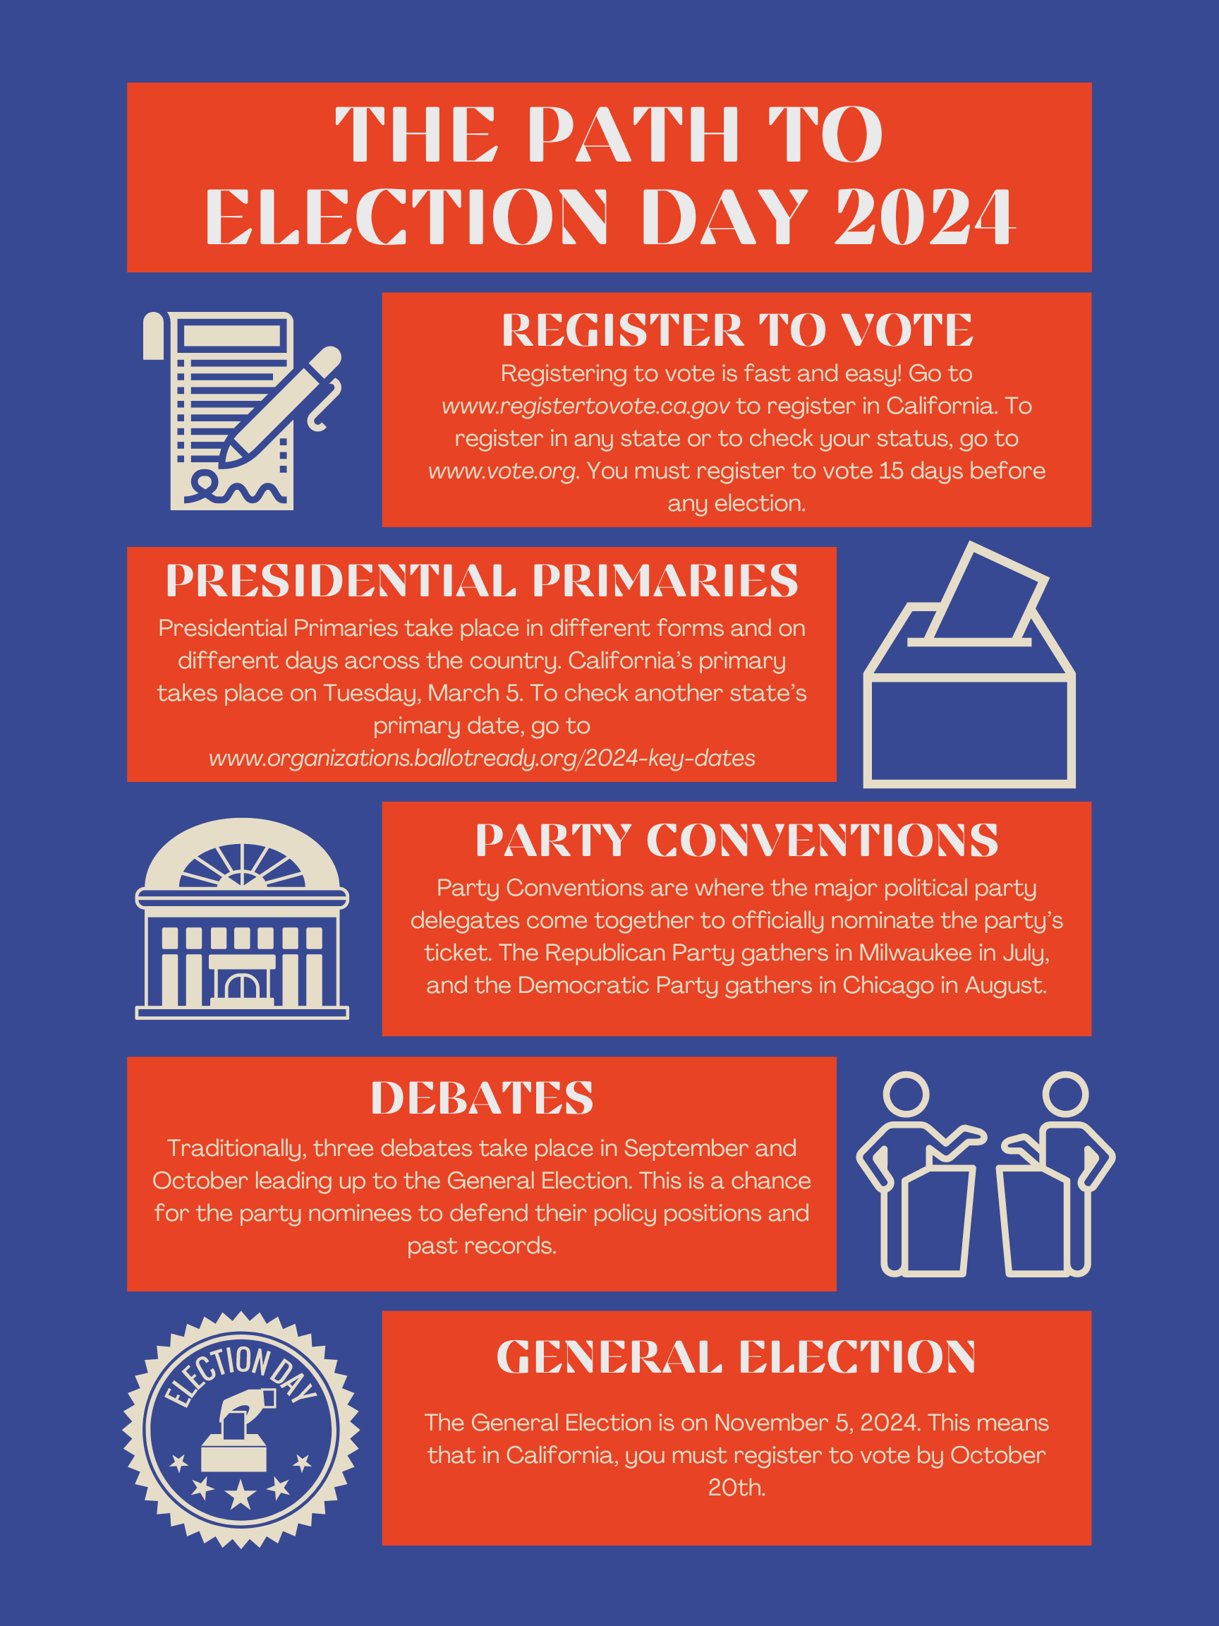

May 2nd Uniform Election
- Last Day to Register to Vote April 2nd
- First Day of Early Voting April 20th
- Last Day to Apply for Ballot by Mail April 20th
- Last Day of Early Voting April 28th
- Election Day May 2nd
If you have any questions, please call/email us
903-693-0370
lmason@co.panola.tx.us
Kelsey.lake@co.panola.tx.us

110 South Sycamore Street, Room 100
Carthage, Tx 75633
March 3rd Primary Election
- Last Day to Register to Vote February 2nd
- First Day of Early Voting February 17th
- Last Day to Apply for Ballot by Mail February 20th
- Last Day of Early Voting February 27th
- Election Day March 3rd
May 26th Primary Runoff Election
- Last Day to Register to Vote April 27th
- First Day of Early Voting May 18th
- Last Day to Apply for Ballot by Mail May 15th
- Last Day of Early Voting May 22nd
- Election Day May 26th
November 3rd Uniform Election
- Last Day to Register to Vote October 5th
- First Day of Early Voting October 19th
- Last Day to Apply for Ballot by Mail October 23rd
- Last Day of Early Voting October 30th
- Election Day November 3rd
Important 2026 Election Dates

